

**Education & Industry Training Systems (EITS)’s**

**Client David Hunt ICTICT509 Date June 2018**

# **Creative Commons information**

**Project Summary**

|  |  |
| --- | --- |
| 1. Region/Unit |  |
| 1. Location |  |
| 1. Program |  |
| 1. Project Number |  |
| 1. Project Description |  |

**Version history**

|  |  |  |  |
| --- | --- | --- | --- |
| 1. **Version no.** | 1. **Date** | 1. **Changed by** | 1. **Nature of amendment** |
| 1. **0.1** |  |  | 1. **Initial draft.** |
|  |  |  |  |
|  |  |  |  |
|  |  |  |  |
|  |  |  |  |

**Contents**

**Creative Commons information** ii

**1.** **Purpose of this document** 1

**2.** **Preliminary Background Info** 1

**3.** **Hardware** 1

**4.** **Software** 1

**5.**  **People/Visitor Interaction:** 2

**6.** **Processes** 2

**7.** **Data** 2

**8.** **Requirements Specifications** 2

**9.** **Proposed project** 5

**10.** **Timeline and Project process** 5

**11.** **Budget** 6

**12.** **Sample Screens and Reports** 8

**13.** **Database** 9

**14.** **Data Flow Diagrams** 10

**15.** **Draft UML Diagrams** 11

**16.** **ERD diagrams** 14

**17.** **Screen shots of Zoho project management for David** 15

**18.** **Annexures** 18

# **1. Purpose of this document**

The purpose of this document is to determine the ‘as is’ and ‘to be’ business processes.

# **2. Preliminary Background Info**

Education and industry training systems is looking to get our support in programming a desktop web application that speeds up the process in delivering options of courses available to students. This is done by giving suggestions based on the clients industry choice, The application tracks the level of interest and choices by students.

Specifically, EITS would like the system to assist clients with:

• Welcoming students to the college

• Gathering the students details by registration

• Tracking the students choices and industry interests

• Deliver a course/training option based on the selection of the industry

# **3. Hardware**

• Desktop computer

• Web server or web hosting – SQL Server

# **4. Software**

• Valid, compatible, standard-based development in Java

• MySQL - Database

• Apache

• GUI to greatly enhance aesthetic and user experience

# **5. People/Visitor Interaction:**

• Staff

• Potential Students

• Existing Students

• Administration

# **6. Processes**

• Welcome user to EITS – Login/Register screen

• Present the user with a list of industries that they can choose from

• After selecting an industry, it will display courses relating to that industry

• The user will select a course and it will display the relevant units to the course and allow the user to select the course as the one they want to study

• Log out (Current timestamp)

# **7. Data**

|  |  |  |  |
| --- | --- | --- | --- |
| **Users** | **Industry** | **Courses** | **Units** |
| ID | ID | ID | ID |
| Username | Name | Name | Code |
| Password |  | IndustryID | Description |
| Email |  |  | CourseID |
| CourseID |  |  |  |
| Time |  |  |  |
| Access |  |  |  |

# 

# **8. Requirements Specifications**

**Specific requirements** of the desktop development environment application to be developed in brief.

**Product Perspective**

This software product is intended to be displayed in the office of EITS to gather and display information about the courses for potential students/customers. The applications main user interface will be where users can operate all the provided functionality. The application will be an interface for user data and the execution of provided functionalities. To use the application, users are required to register through the desktop interface. Whenever a new user is registered, all the required data will be added into the database and a predefined user id will be assigned for the user in the database. A user will be able to login and logout of the system anytime they want to in the office of EITS. From the user point of view, user will have functionality to select a Course industry. The system will then display options of the Courses available based on the industry. The user will then have functionality to select the Course. The system will then display options of Courses details/units. Language specific compilers and debuggers, database MSQL, Java, GUI and project management tools (Zoho, Git, etc).

**System Features**

**Student procedure**

**Register:** Purpose of this feature is to register the user to the system.

Normal Flow of Events

• User opens the registration page

• User specifies their information

• System validates the specified information

• User is registered to the system

Alternative Event Flow

• User cannot be registered to the system due to the username being taken and the email not having an @ or a .com

**Login:** Purpose of this feature is to login to the system with user credentials in order to use system.

Normal Flow of Events

• User opens the login page

• User tries to login to the system with their credentials

• System validates the specified information

• User is logged into the system

Alternative Event Flow

• User cannot log into the system due to incorrect username/password

**Gather:** Purpose of this feature is to gather knowledge and industry credentials

Normal Flow of Events

• User logs into the system

• System displays a list of Industry credentials

• User selects industry credentials

**Display Course:** Purpose of this feature is to display courses based on industry knowledge and credentials

Normal Flow of Events

• User is logged into the system

• System displays a list of courses

• User selects a course

**Display Course units:** Purpose of this feature is to display course based on knowledge and credentials

Normal Flow of Events

• User is logged into the system

• System displays a list the of course details

**Staff Panel**

**System Features**

**Login:** Purpose of this feature is to login to the system with staff credentials in order to use system.

Normal Flow of Events

• Staff opens the login page

• Staff tries to login to the system with their credentials

• System validates the specified information

• Staff is logged into the system

Alternative Event Flow

• Staff cannot log into the system due to incorrect username/password

**Gather:** Purpose of this feature is to gather Students credentials

Normal Flow of Events

• Staff logs into the system

• System displays a list of Students credentials

**Admin Panel**

**System Features**

**Login:** Purpose of this feature is to login to the system with Admin credentials in order to use system.

Normal Flow of Events

• Admin opens the login page

• Admin tries to login to the system with their credentials

• System validates the specified information

• Admin is logged into the system

Alternative Event Flow

• Admin cannot log into the system due to incorrect username/password

**Insert data:** Purpose of this feature is to insert knowledge and industry course, unit, staff credentials

Normal Flow of Events

• Admin logs into the system

• System displays an area to insert Industry, course, unit, staff credentials.

# **9. Proposed project**

EITS is looking to get The Best Team Evers (TBTE) support in programming a desktop web application that speeds up the process in delivering options of course’s available to students. This is done by giving suggestions based on the client’s industry choice & by tracking the level of interest and choices by students. The user’s experience must be seamless; high performing, fast, and responsive. TBTE will design and develop a desktop application that will anticipate and respond to user needs and expectations, provide a smooth navigational experience, and appropriately reflect EITS’s brand in look and feel.

***Waterfall Methodology:*** Waterfall is a sequential model building development that happens in a series of steps from requirement analysis to launch.

**source code control process:** By using Git and Source Tree we are avoiding source code conflicts***. Once*** a developer has updated the code they commit. Then they push the file. Once the file is pushed to the Master repository the other developers pull the code to their local repository.

Fetch then merge (Combines 2 branch heads together into one branch. Usually with the master branch)

Commit (Store your files to a state/revision on your local repository).

Push (upload or sends all of your commits to the Master Repository)

Pull (Uploads or send s all your commits from the Master repository

to your local repository and merges your most recent commit)

# **10. Timeline and Project process**

The Best Team Evers (TBTE) process is comprehensive and built for success around planning. Everything is managed via a virtual ecosystem (Zoho) – so all progress, milestones, communication and approval happen in real time in an environment designed to be extremely collaborative with the client. This is an estimated timeline and may be altered during Project Planning.

**Discovery and Planning (Week 1 - 2)**

**Project setup/management –** Project management is done in Zoho, wireframing, Git, accounting, communication, file management, etc.

**Project Planning** – Typing up all that have been communicated, such as extract technical requirements, hosting environments, branding guidelines, client requirements etc.

**Personal development –** Who are the constituents who are going to be using this application? What unique needs/requirements/expectations does each have? What does our design and content need to be aware of to satisfy each of them?

**Site mapping -** Determine a visual representation of each area/pages of the desktop application and how it is architected to fit/flow together. Significant emphasis on future growth – what happens when EITS want to expand? How does the design/architecture lend itself to that?

**Wireframing** - Understand the basic visual guides used in interface design to suggest the structure of the application and relationships between its pages. The applications wireframe is a similar illustration of the layout of fundamental elements in the interface.

**Design planning** – TBTE begin to explore visual styles, moods, themes, elements, etc.

**Visual Design (Weeks 2 - 4)**

After the planning phase, TBTE begin the process of combining the wireframes and mood concepts in to aesthetic compositions, with rounds of revisions and feedback.

**Visual composition** – Conceptual drafts of core templates finalised.

**Programming/Development (Weeks 4 - 5)**

**Java Development** – Based on development of user interaction for an desktop application

**MYSQL** - database

**GUI -** to greatly enhance aesthetic and user experience

**Debugging, Testing, QA, Hand-off (Weeks 5 - 6)**

**Testing and Quality Assurance** – through testing of all areas of the application, states, interactions and dynamic front-end content

**Hand-off** – Coordinated hand-off of all assets, files, source code and documentation to the EITS

# **11. Budget**

TBTE has done through due diligence in relation to the planning materials and design mock-ups to best understand the scope of this project. While our estimate is calculated via hours and an hourly billing rate of $80 per hr, The Best Team Ever (TBTE) prefers to quote as a fixed project cost for the aforementioned scope, to provide maximum planning efficiency and resource management.

Estimated Budget – $ 5920.00

Projects of this size generally have a provisional variance of 15%, to allow for changes, scope additions, extended rounds of revisions.

|  |  |
| --- | --- |
| Functional Scope EITS desktop application | Number of man hours |
| Analysis, Scope, research | 10 hours |
| Section 1 Design/ implication mock ups | 2 hours |
| Section 2 login/ Registration features | 15 hours |
| Section 2 Database | 10 hours |
| Section 3 Administration features | 15 hours |
| Section 4 Content input | 2 hours |
| Section 4 Shift Scheduling | 5 hours |
| System Integration & Testing | 15 hours |
| Staff Training | 2 hours complimentary |
| Total of approximate time (excluding free training) | 74 hours |

# **12. Course Data, Paper Prototypes, Sample Screens & Debugging**

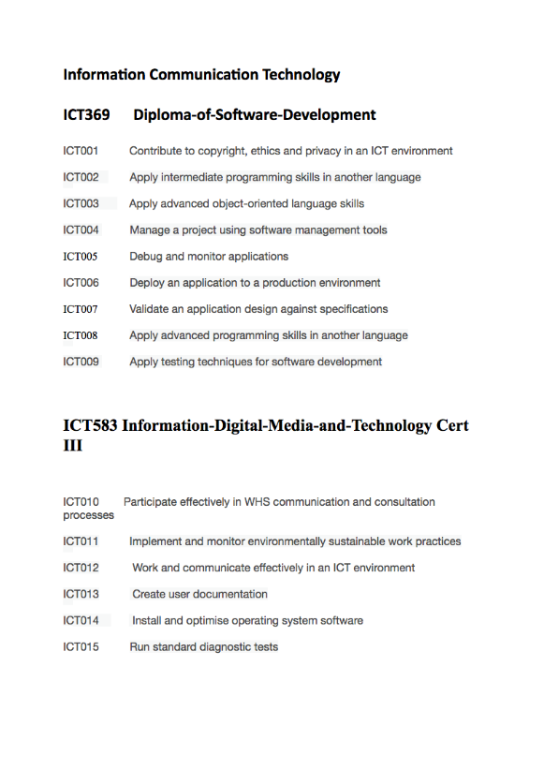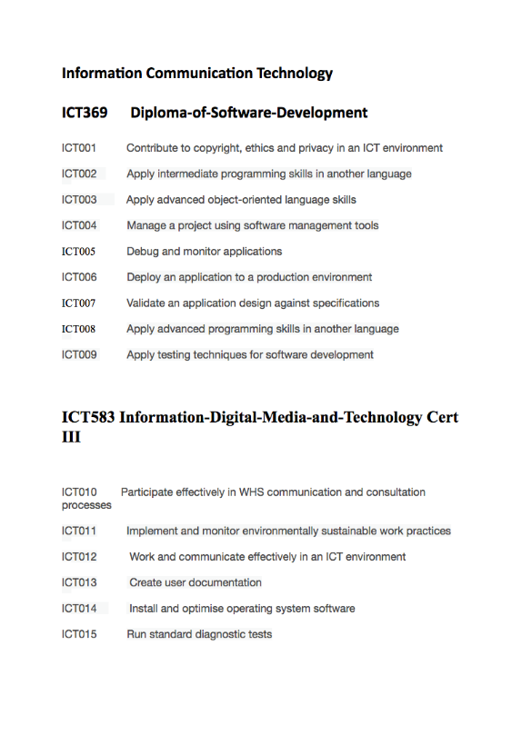Desktop application content course data

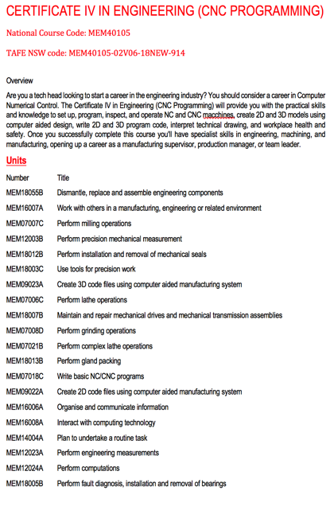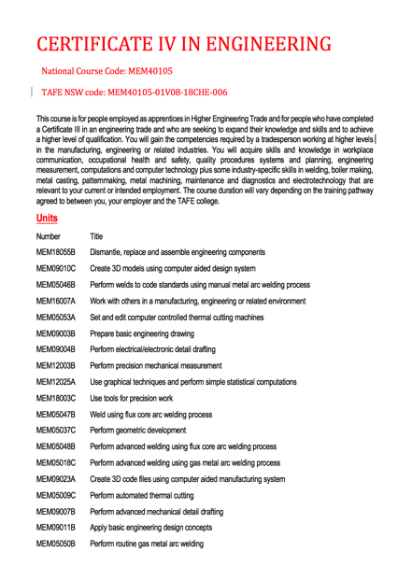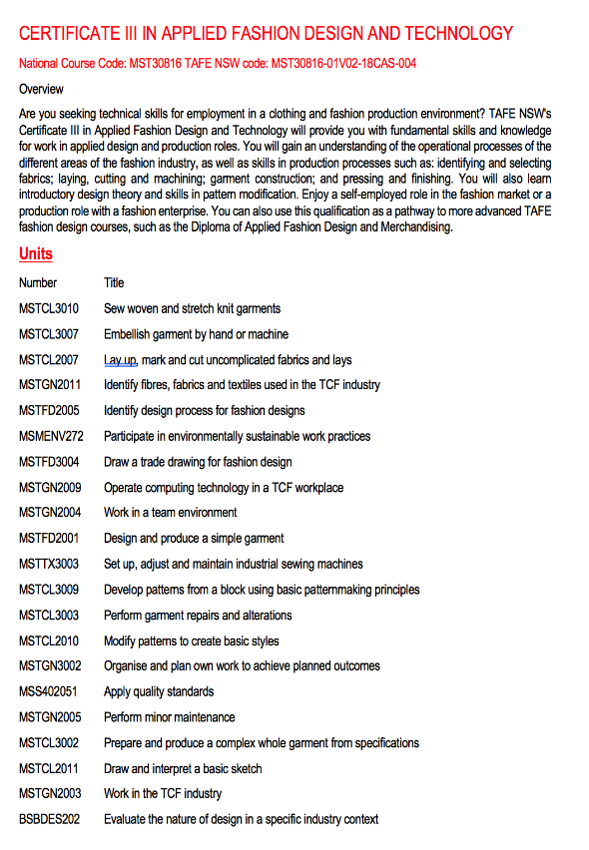

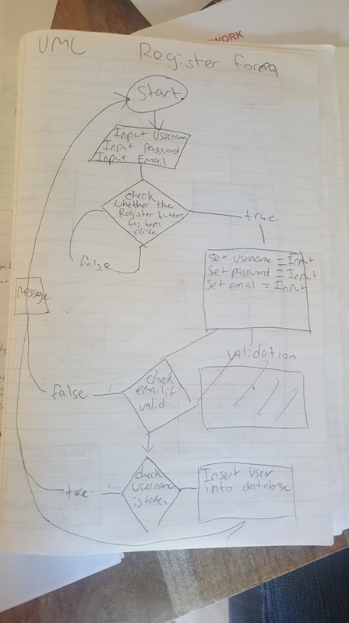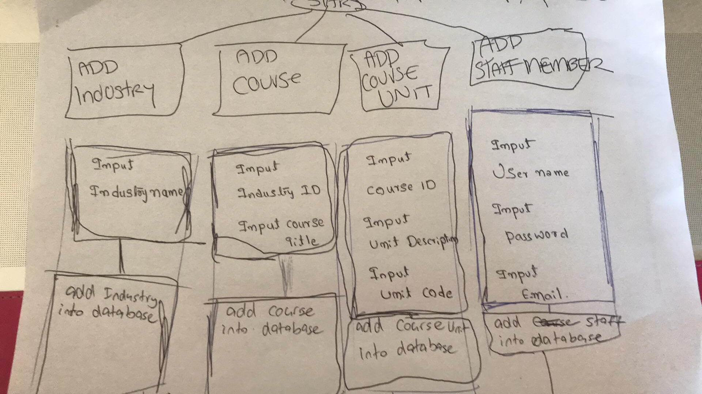**Paper Prototype’s**

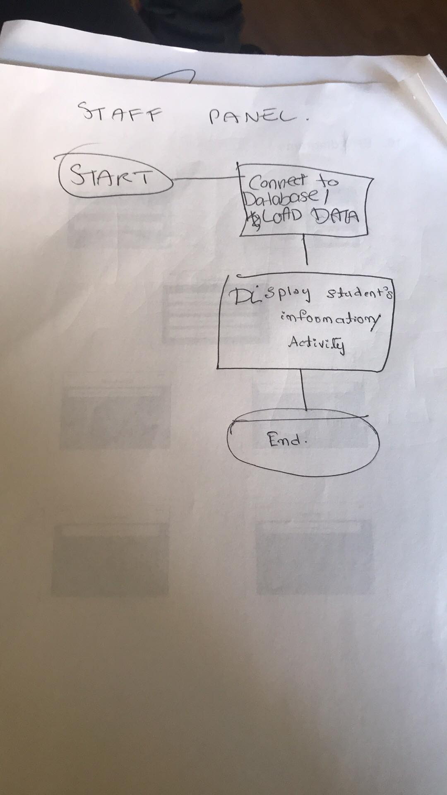

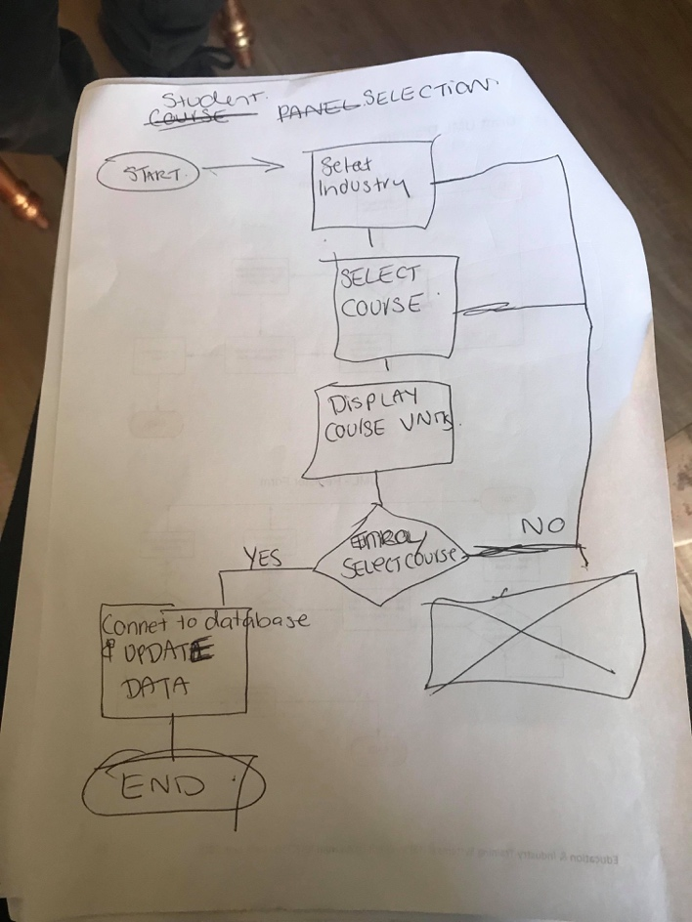

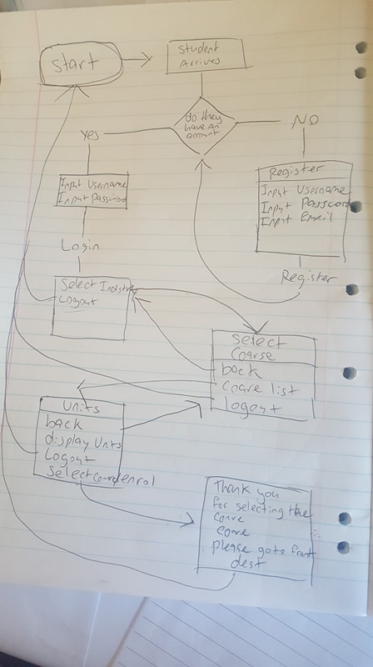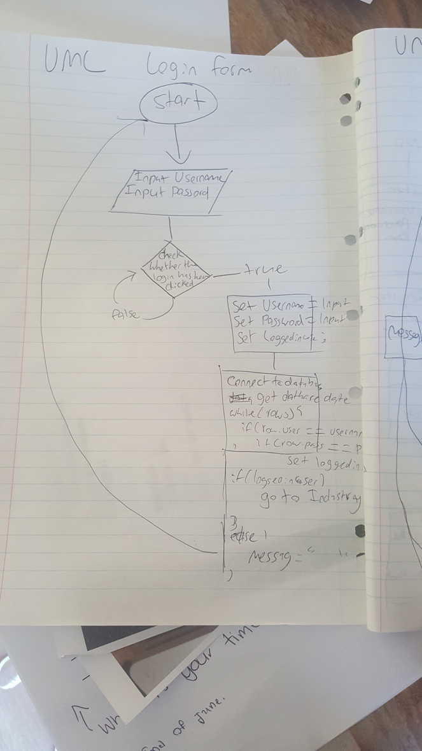

**Debugging**

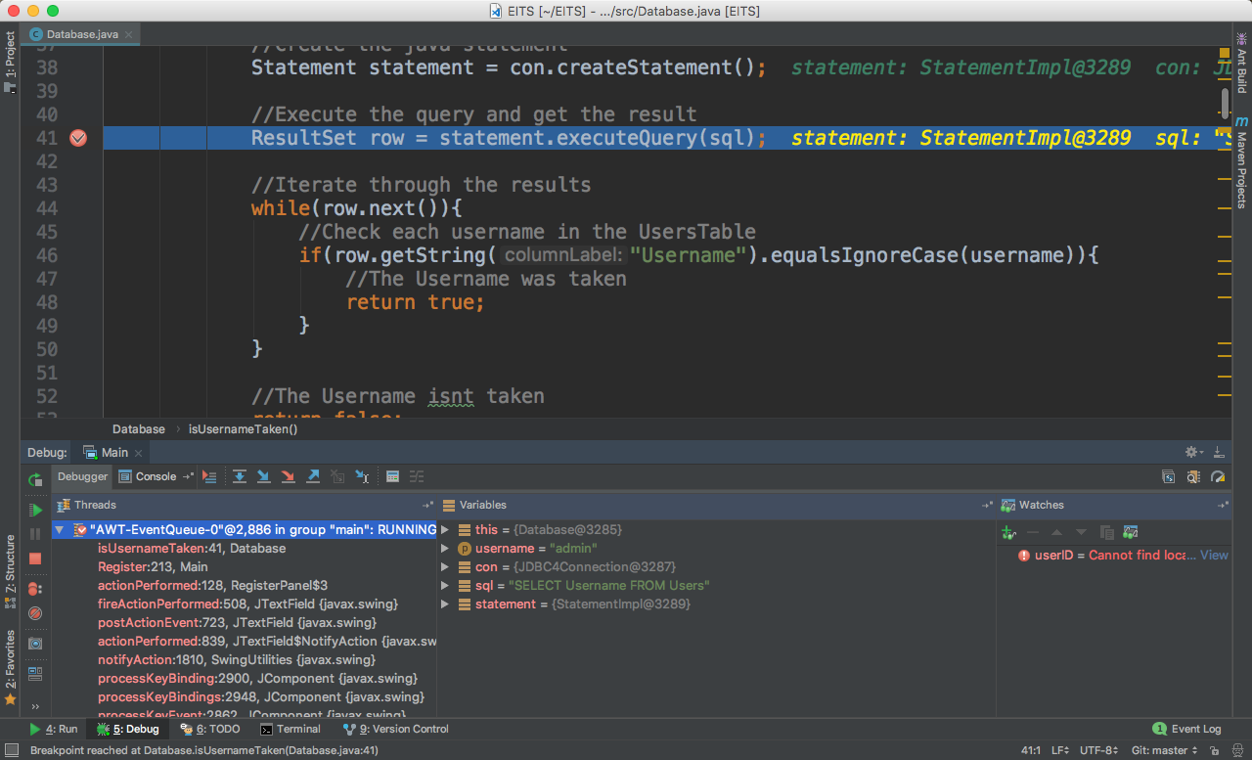Nathan Debug:

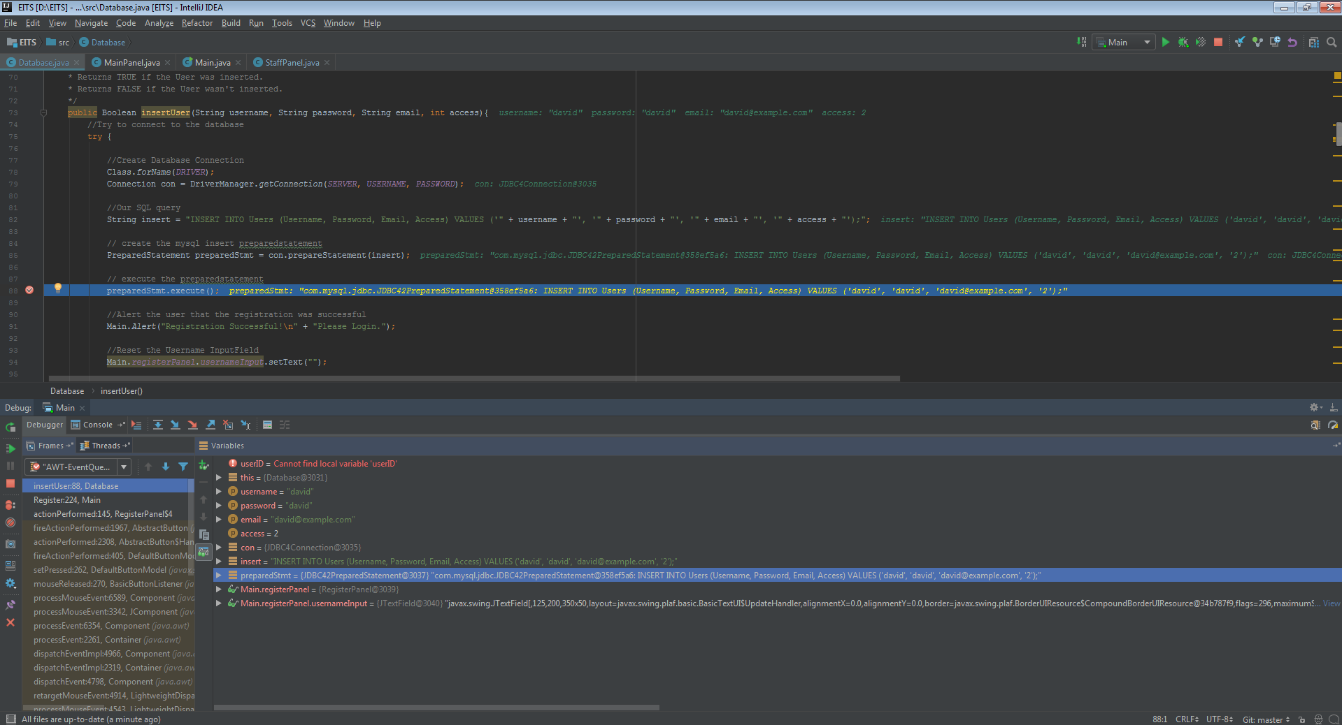Rani Debug:

Kaitlyn Debug:

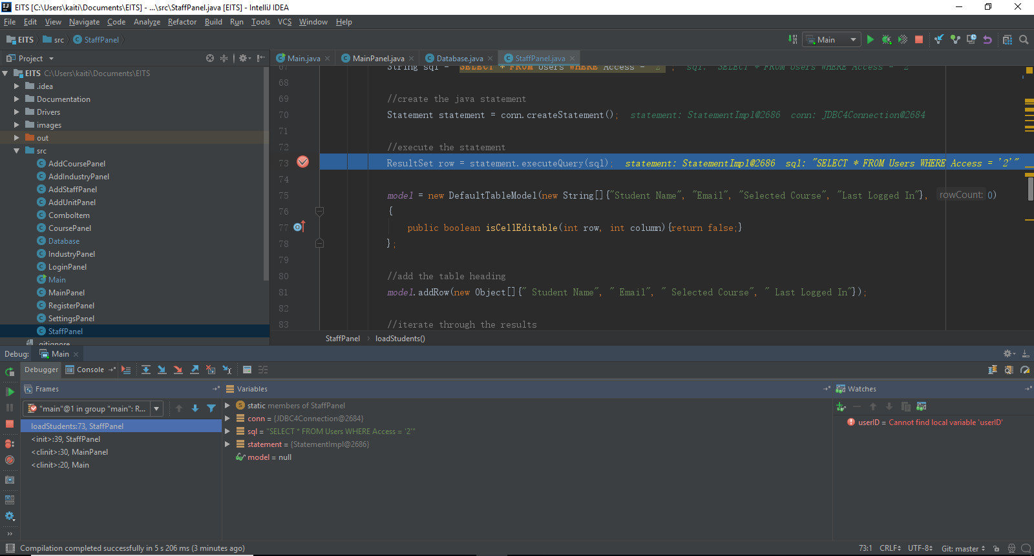

Liana Debug:

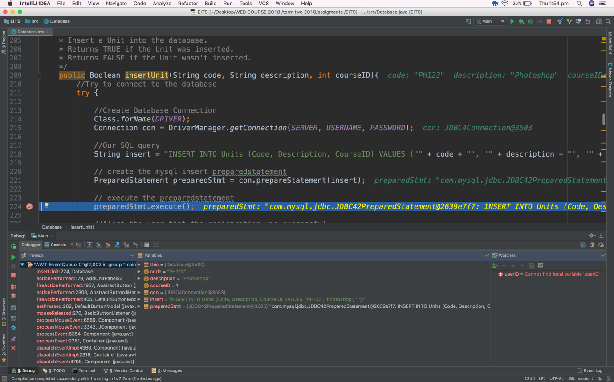

**Final ER Diagram**

Design credentials

* Font: Apple casual
* Image: Chalk background
* Colour pallet:



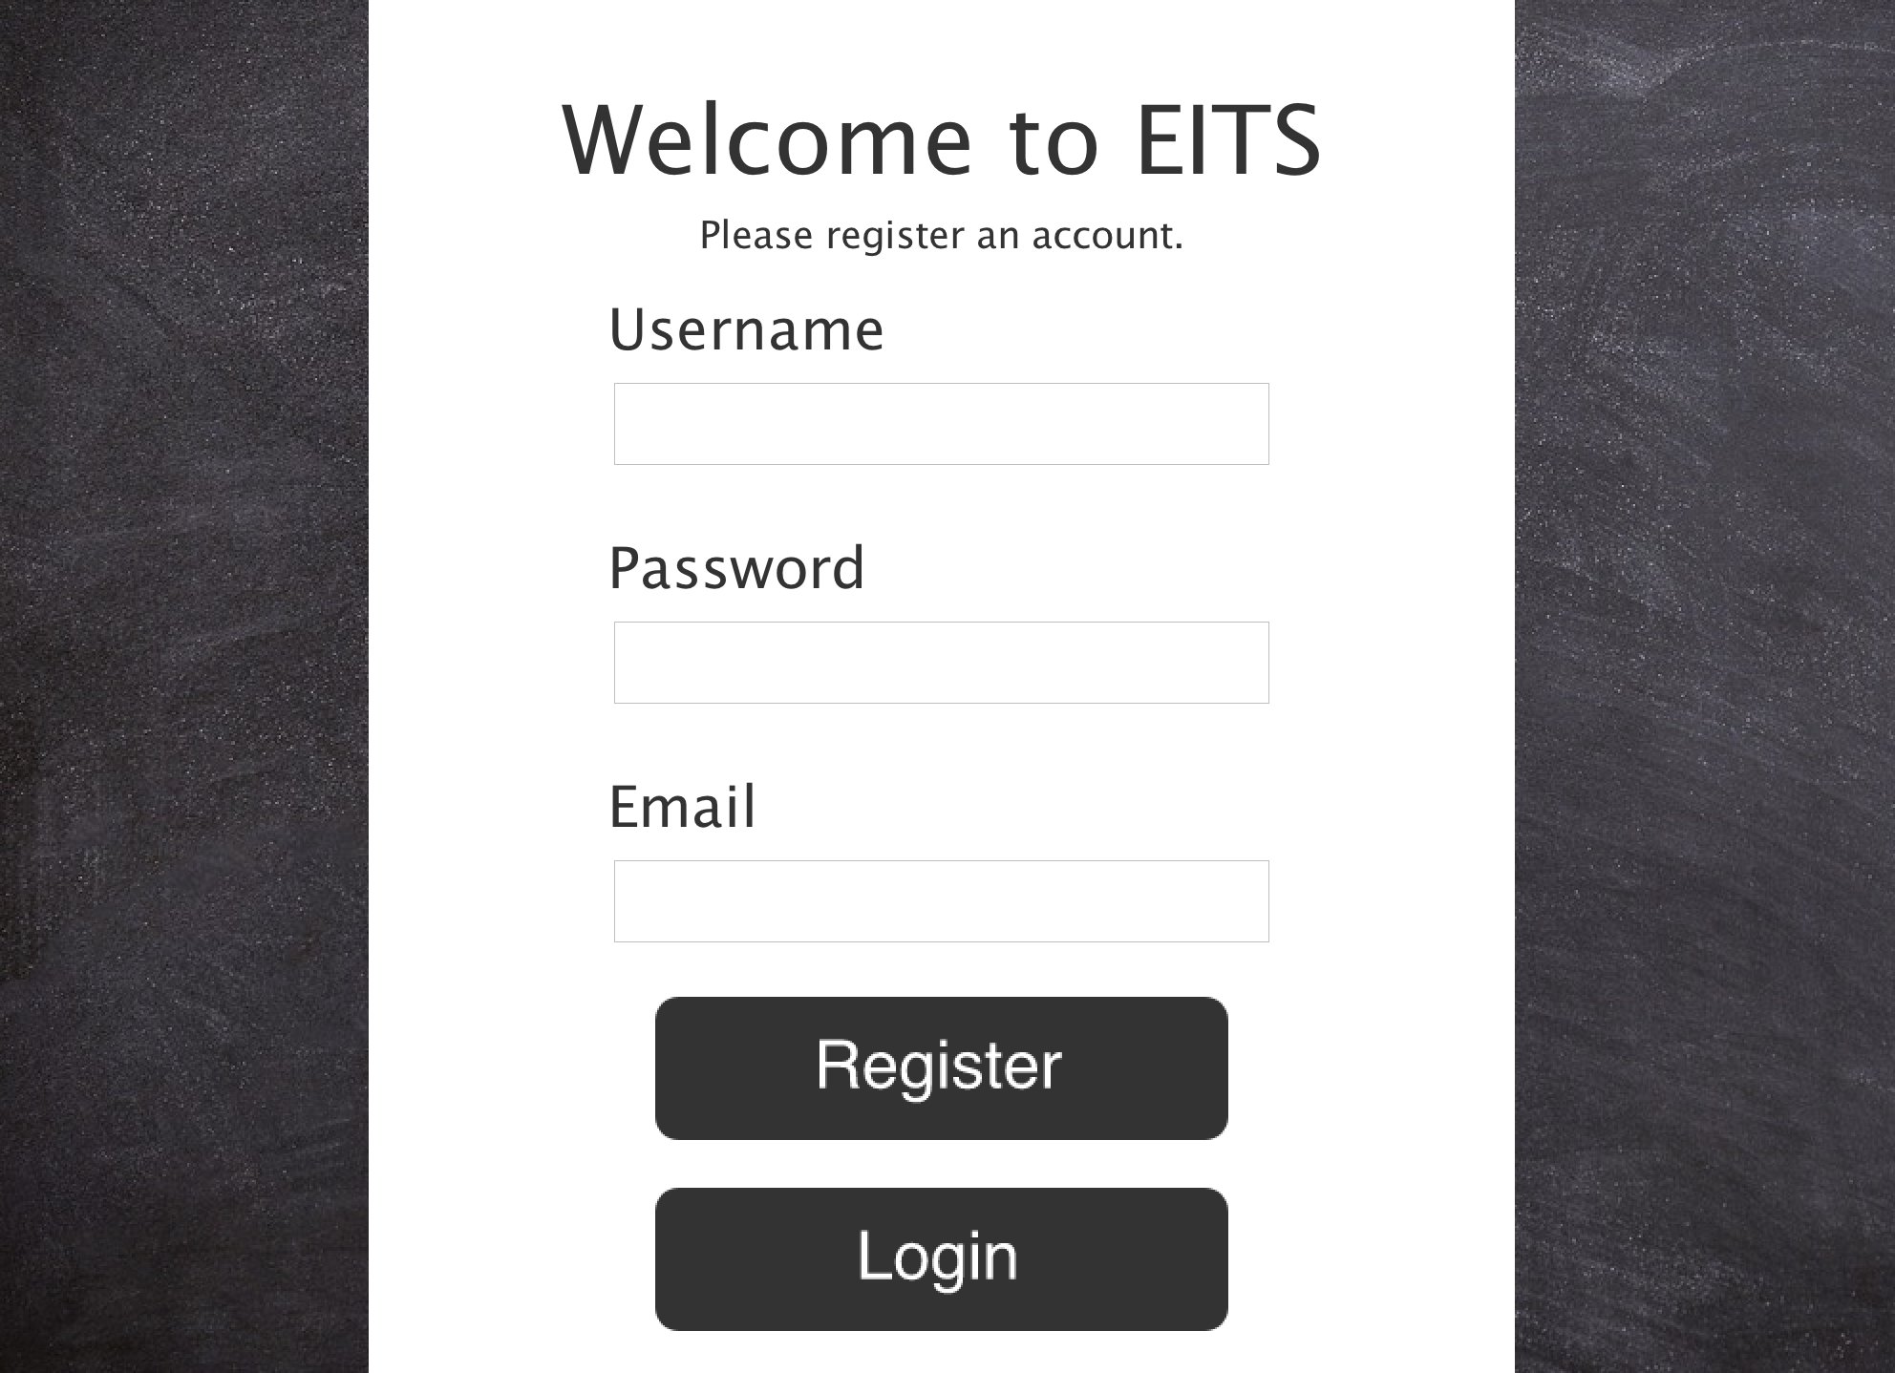

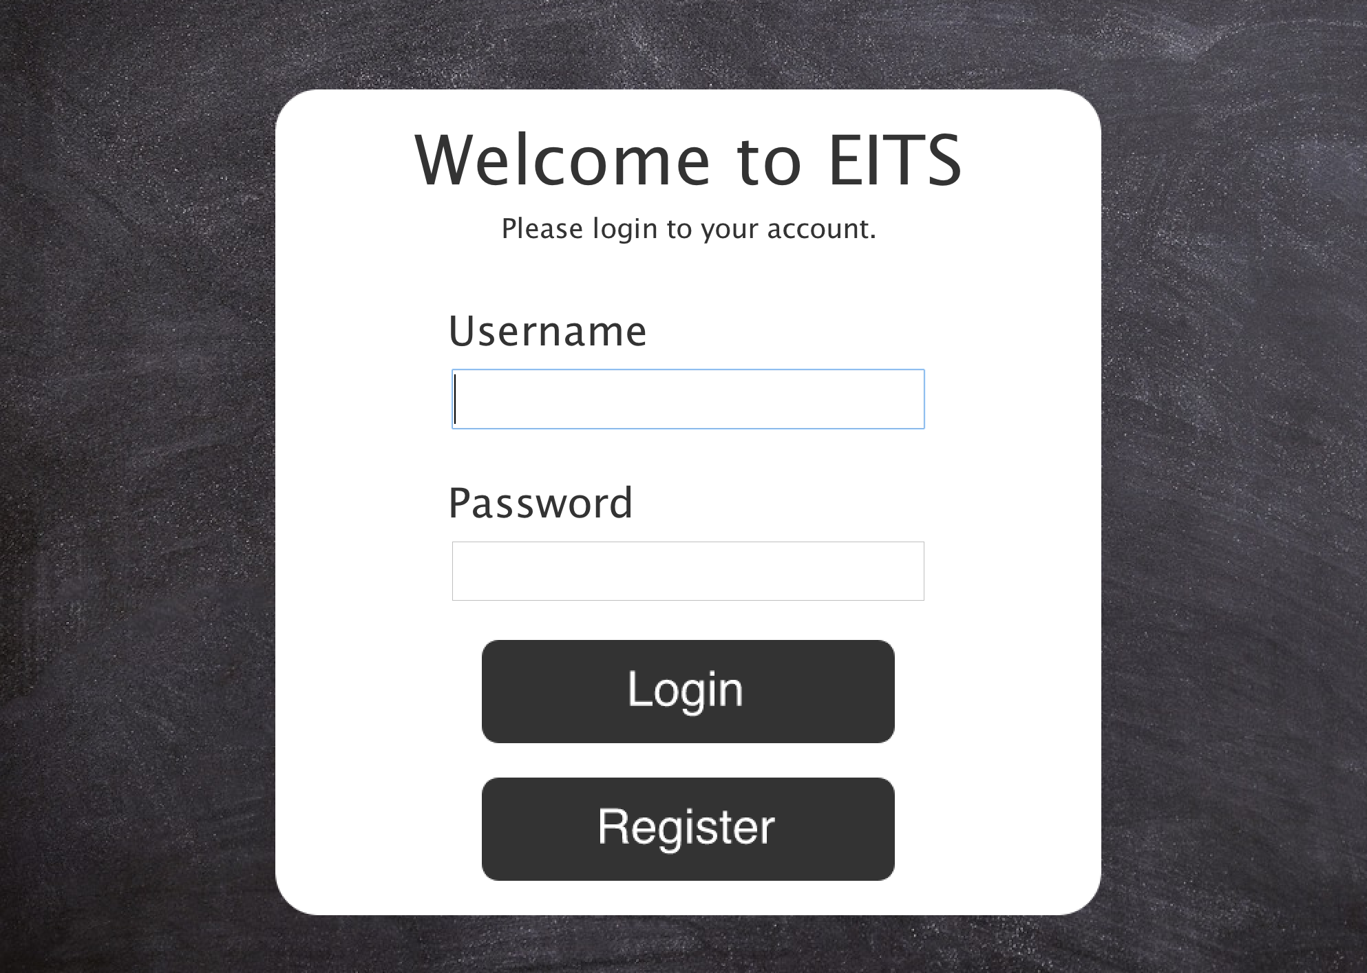

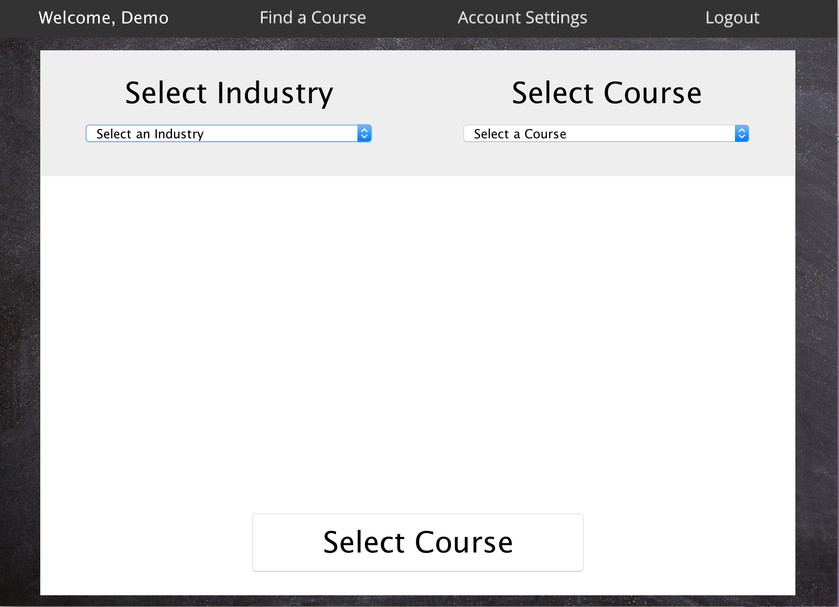

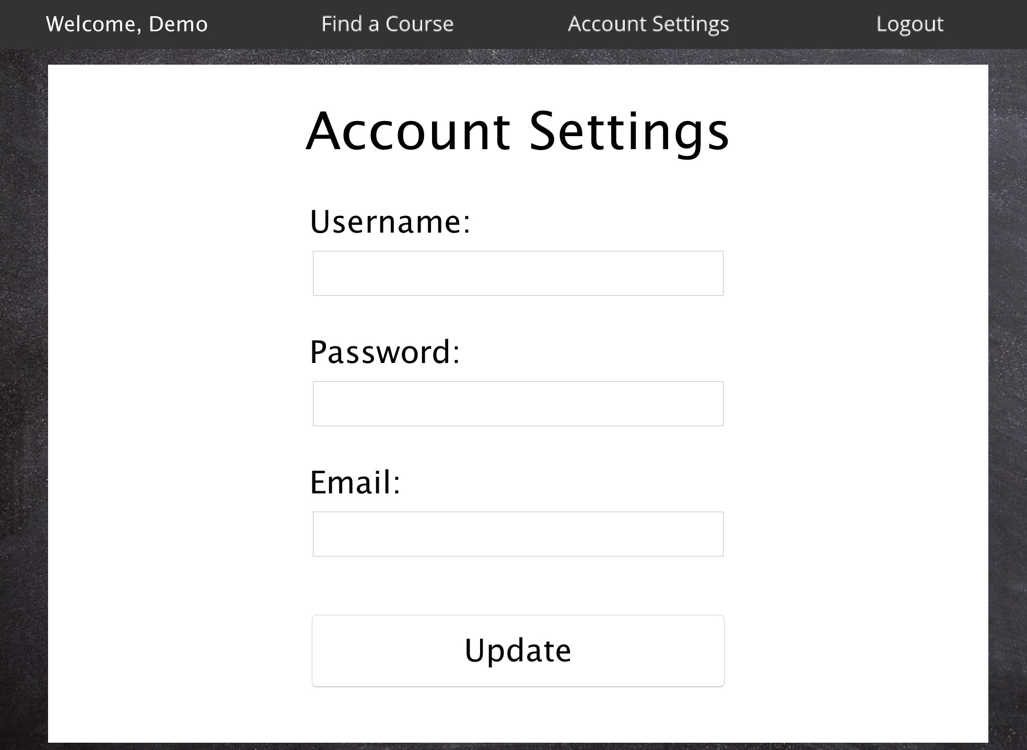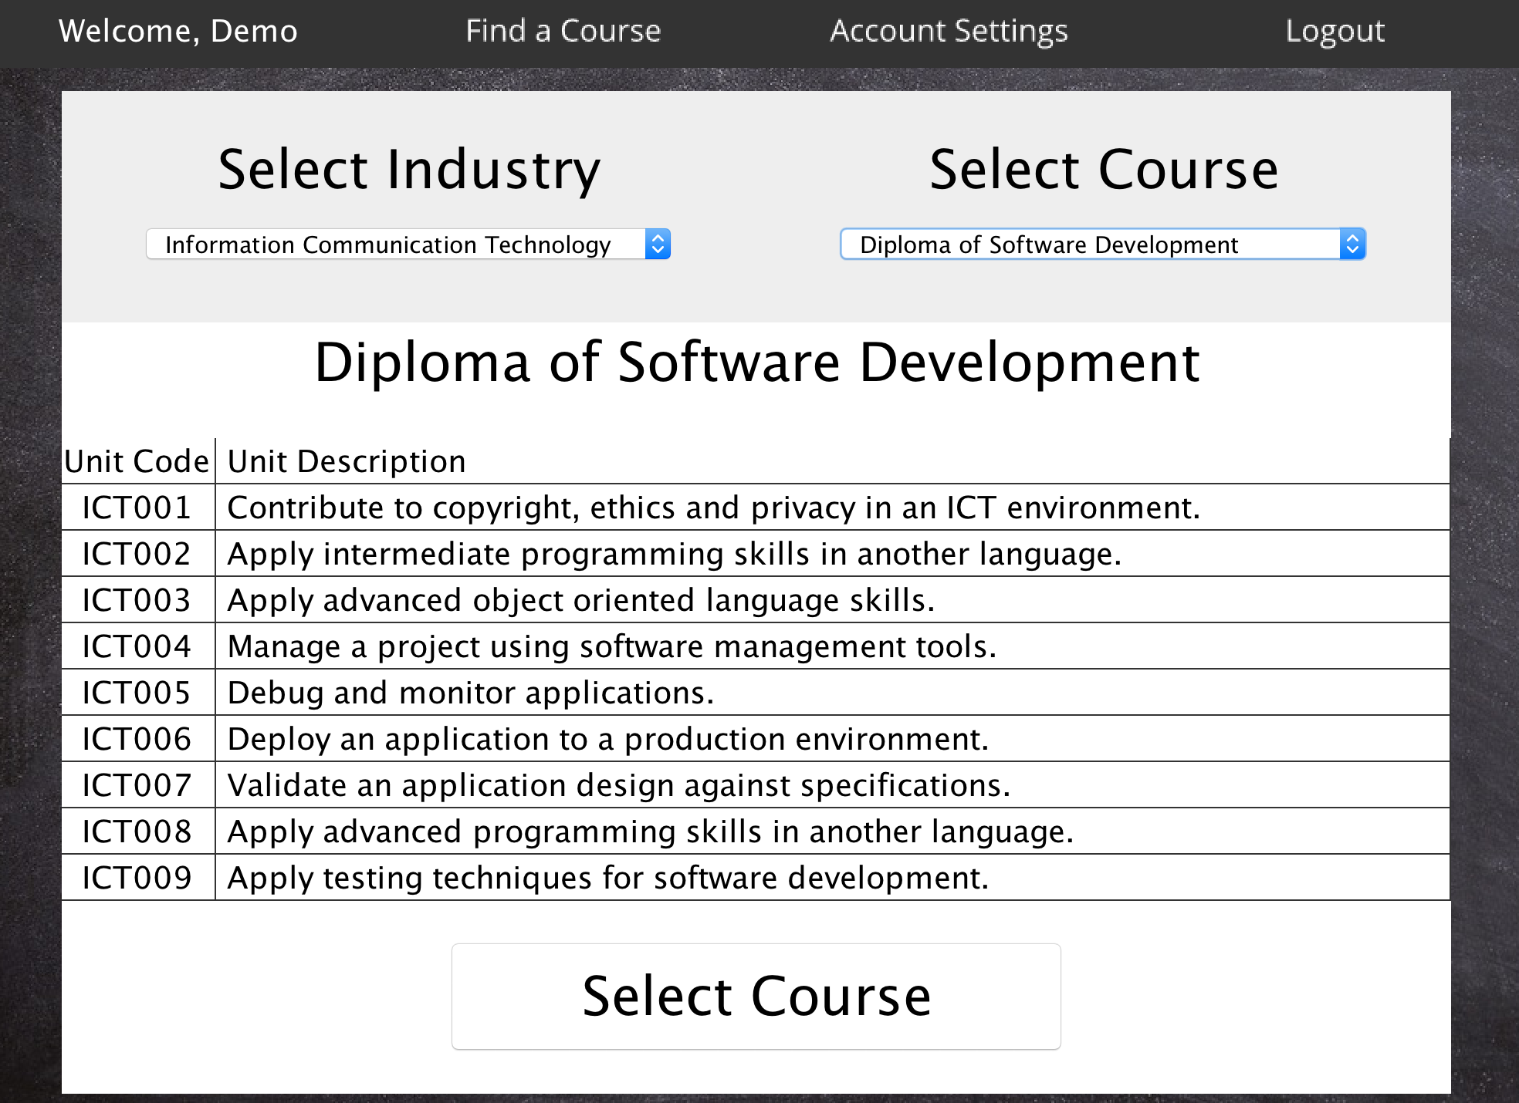

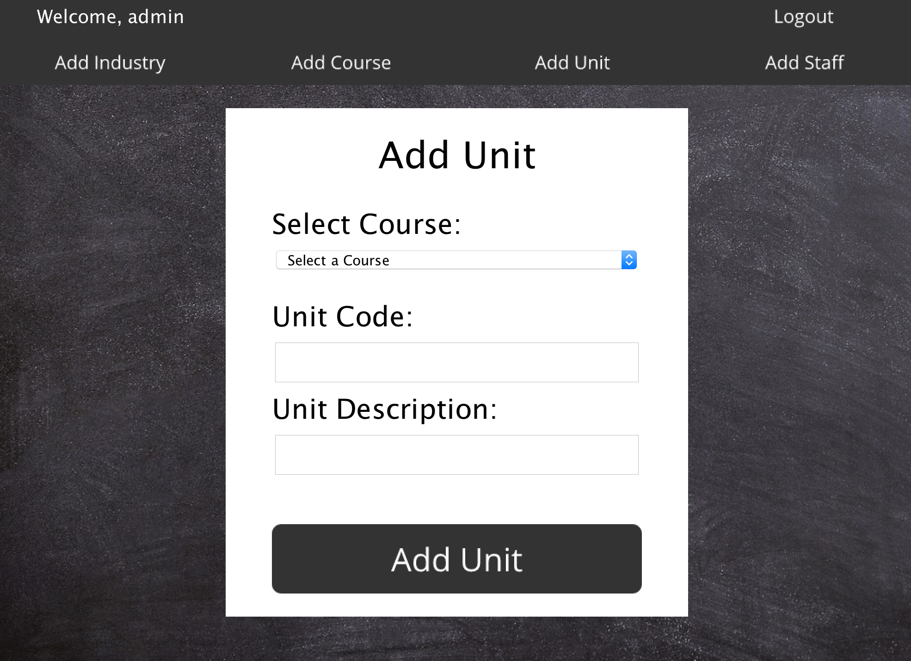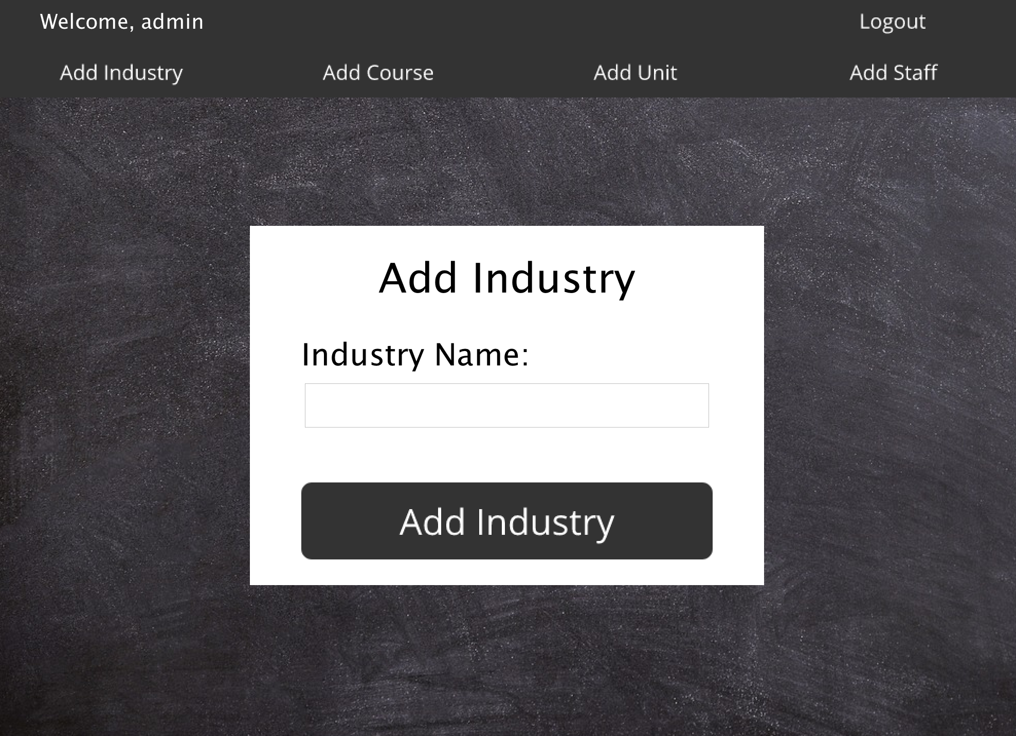

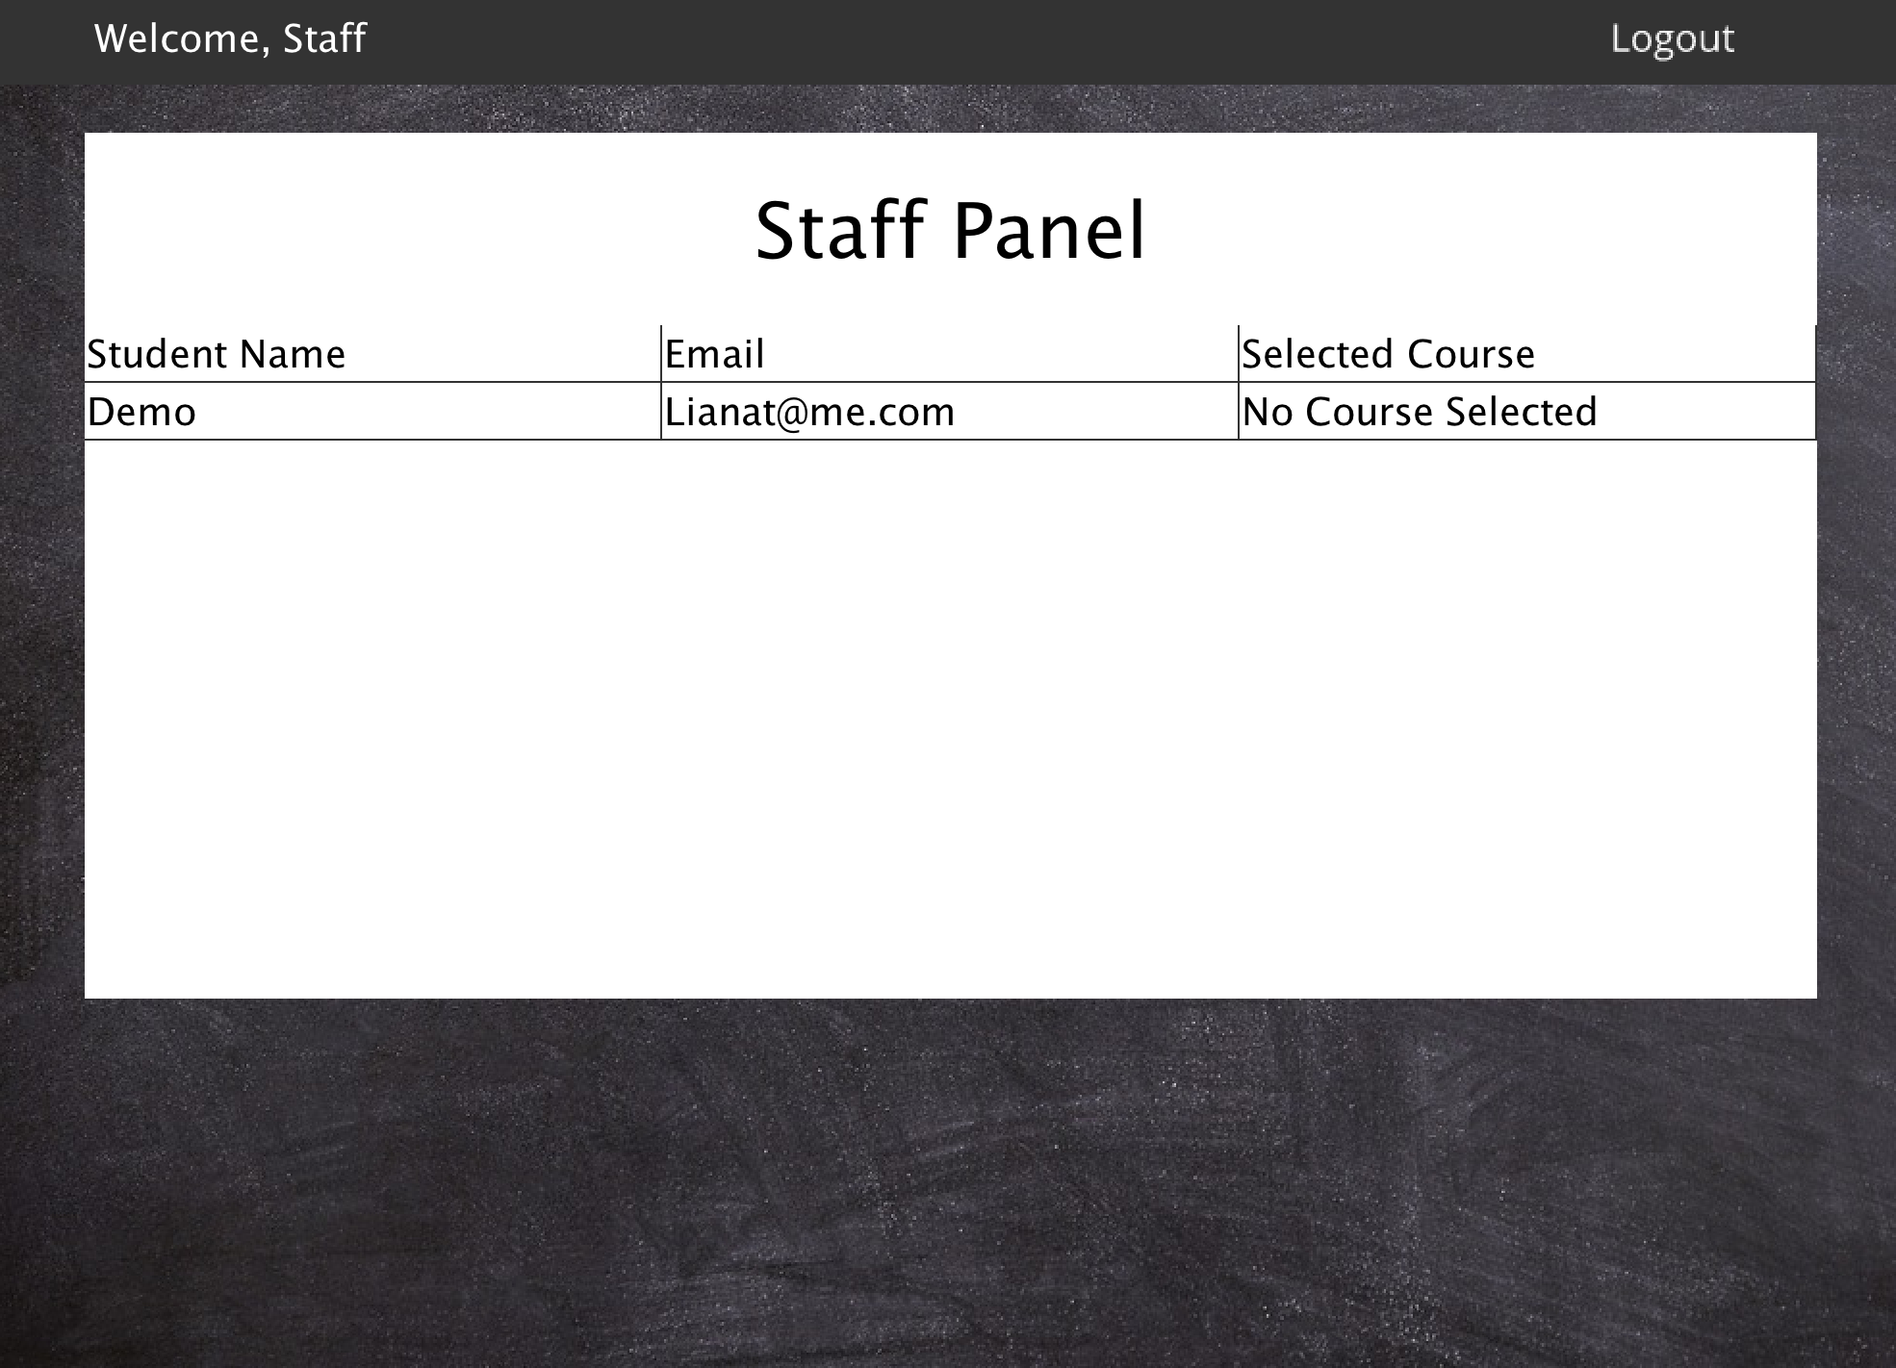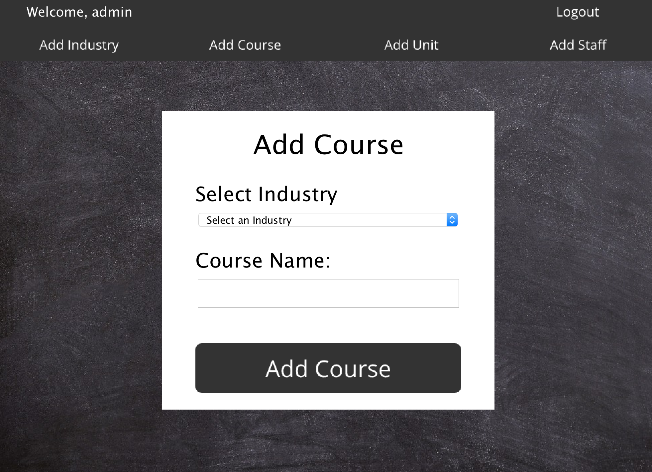

# **13. Database**

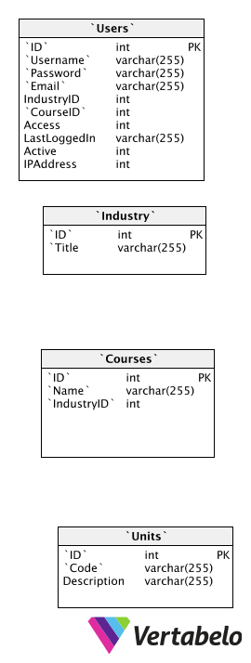

# **14. Data Flow Diagrams**

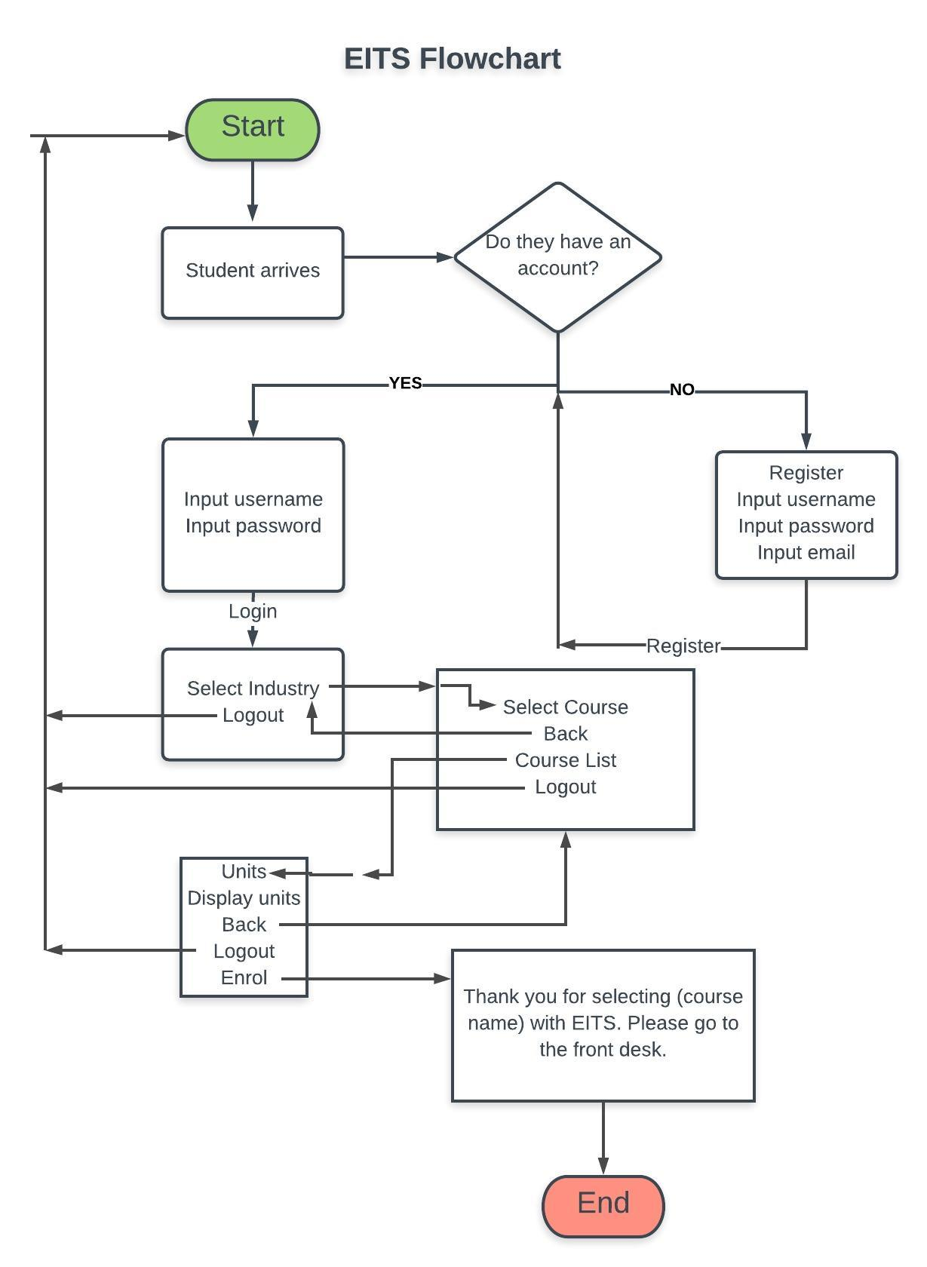

# **15. UML Diagrams**

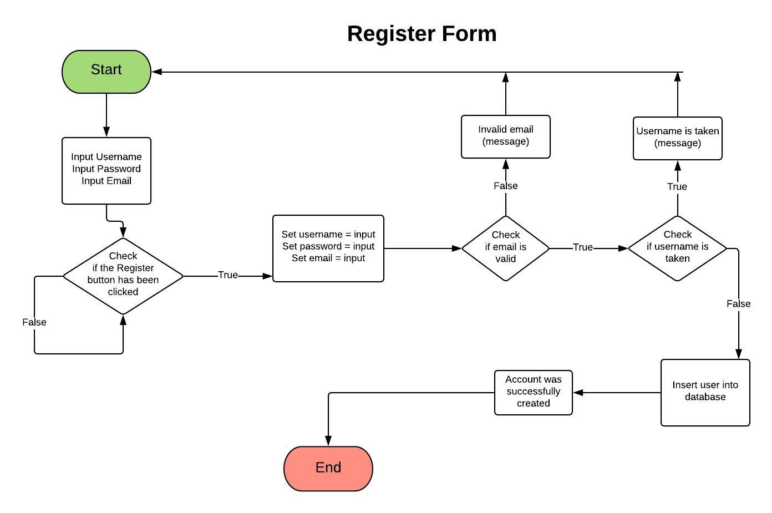

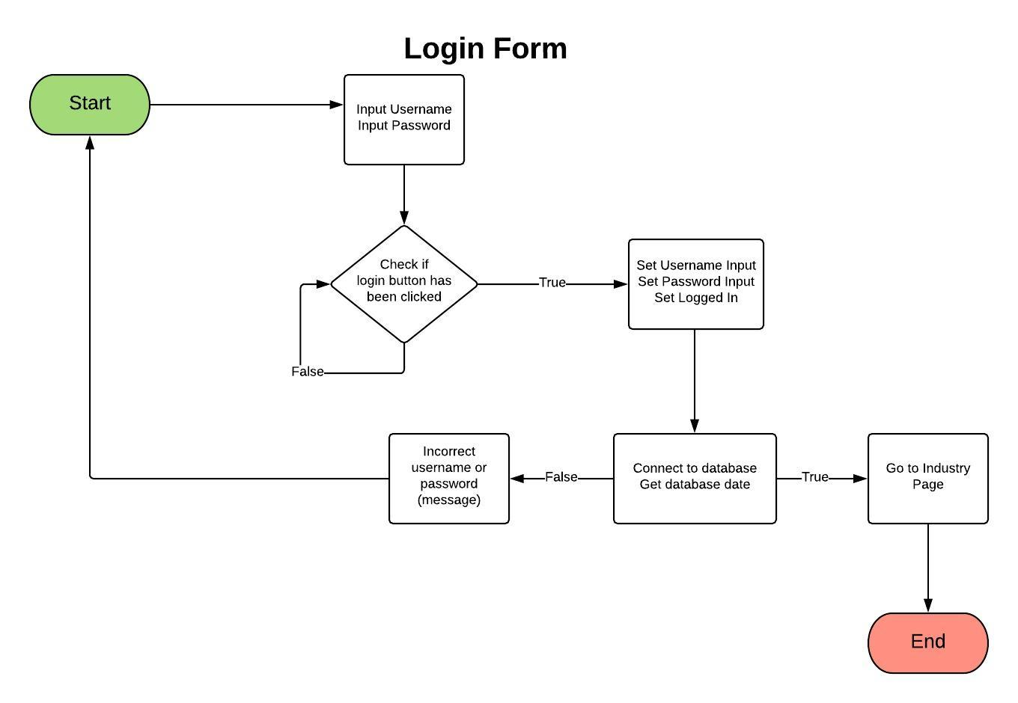

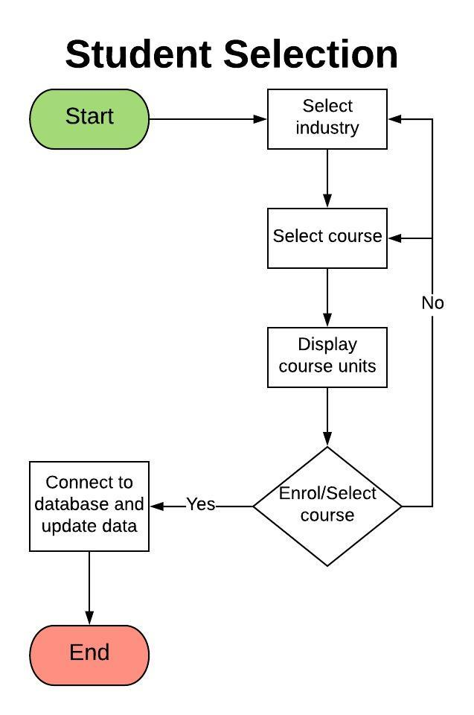

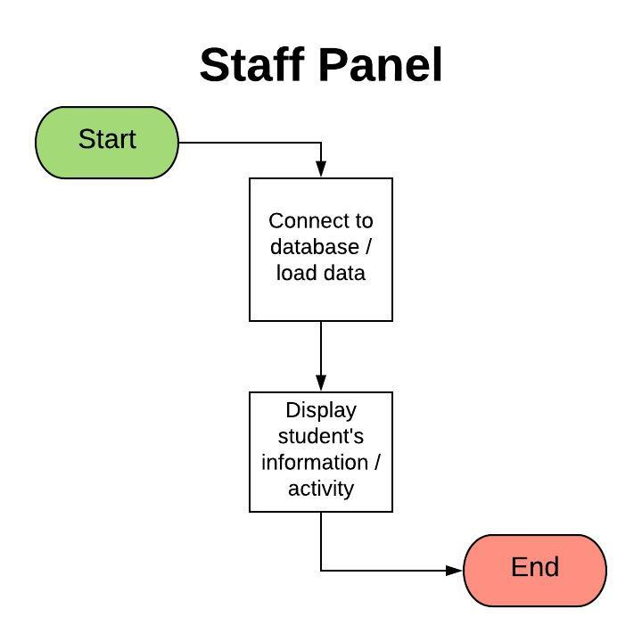

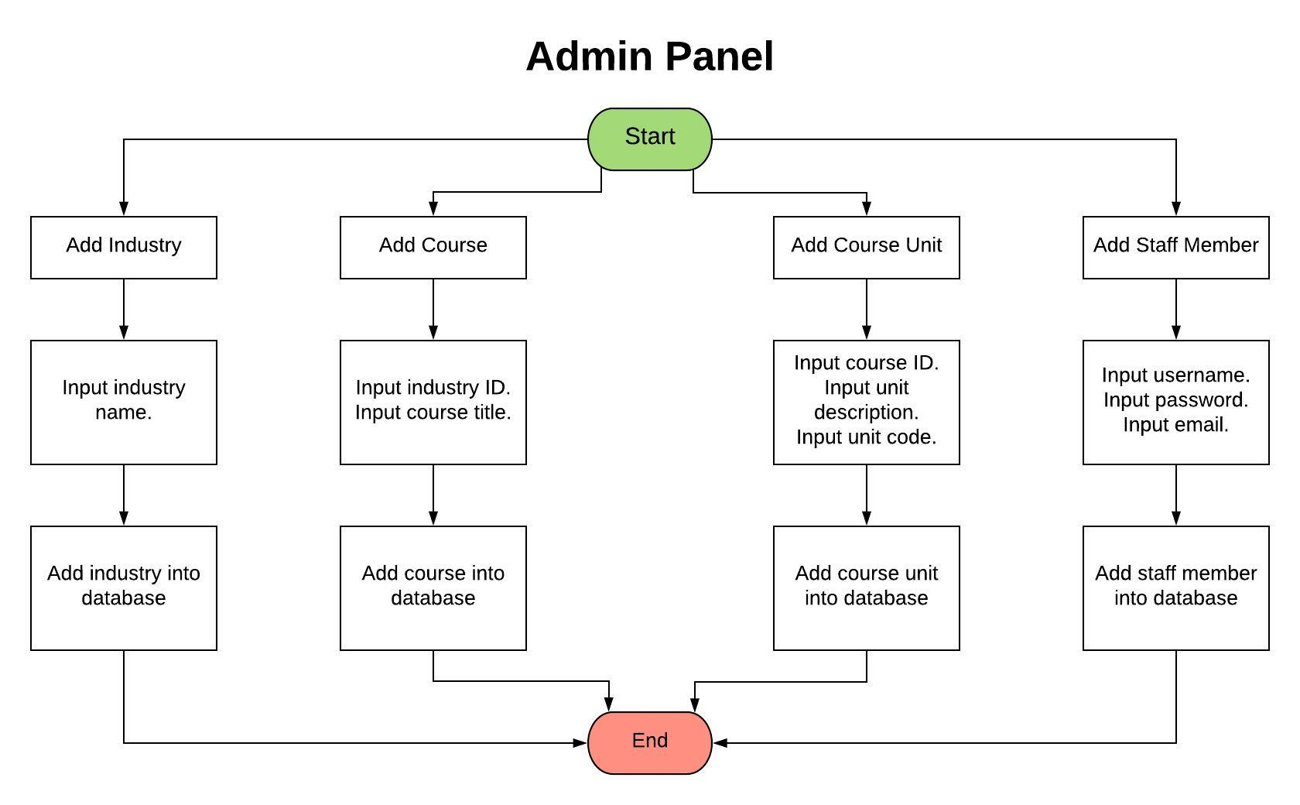

# 

# **16. ER Diagrams**

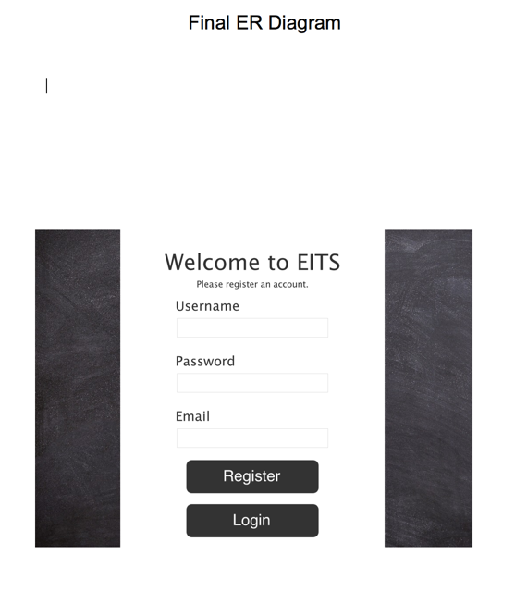

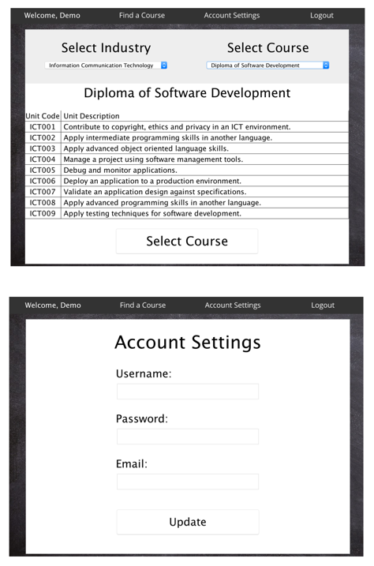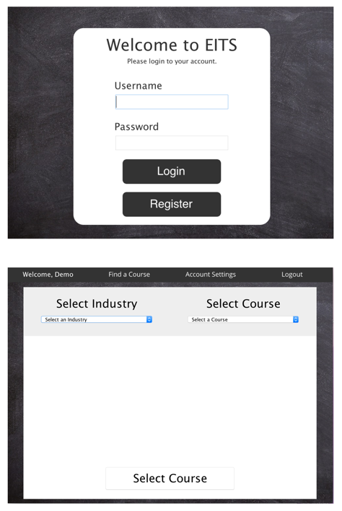

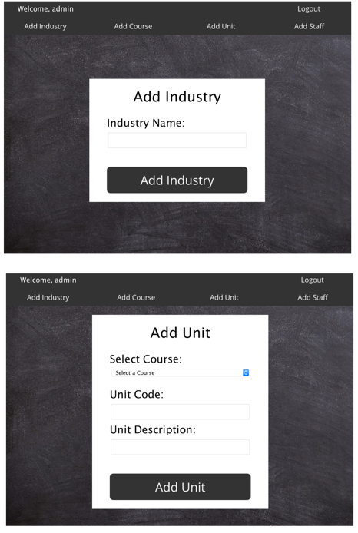

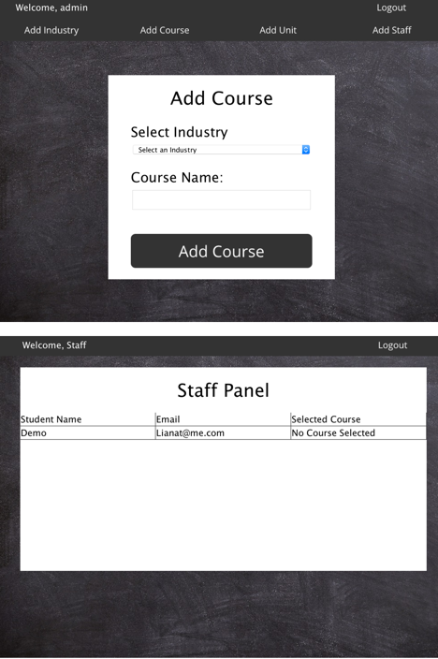

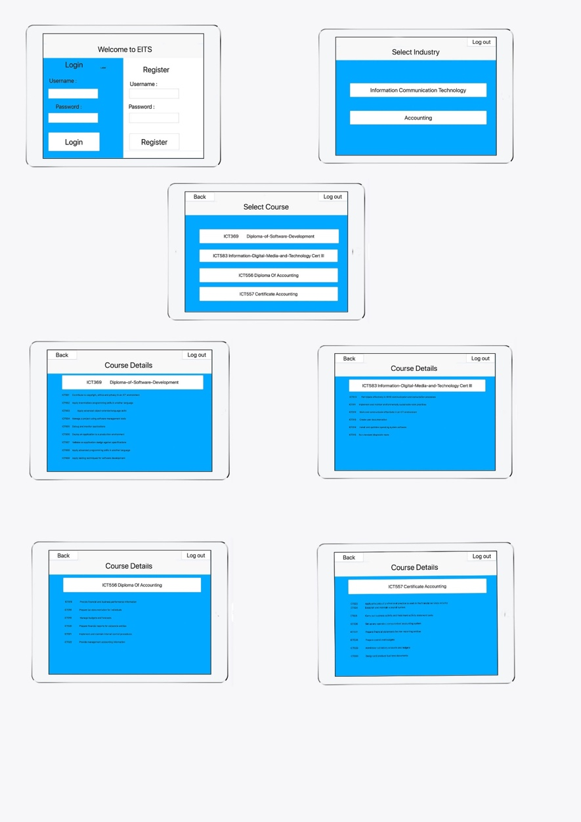**Old** **Diagram**

# **17. Project Management, Source Code Control, and Collaboration Management.**

# 

The reason we decided to use Zoho, Github and Sourcetree for this project is because they are web-based tools that all the stakeholders can access on any operating system.

**The pros of Zoho**

* It's particularly easy to get started for development projects. You can easily set it up with milestones for your projects and keep the activities on track. Very customizable.
* All operating systems can use Zoho because it is a web based application.
* It is also good for task monitoring and projects discussion.
* Excellent for assigning timelines and deadlines.
* Great for Accountability.

**The cons of Zoho**

* Costs - money for the book keeping.
* Pricing.
* No Integration with GitHub.
* As nice and helpful as they are, can be a little difficult to understand on the phone.

**The current software project management tools we would be utilising is**

**Project Management tools**

* Zoho
* MS project

**Source Code Control**

* GitHub
* Sourcetree

**Collaboration Management.**

* Emails
* Facebook
* Zoho

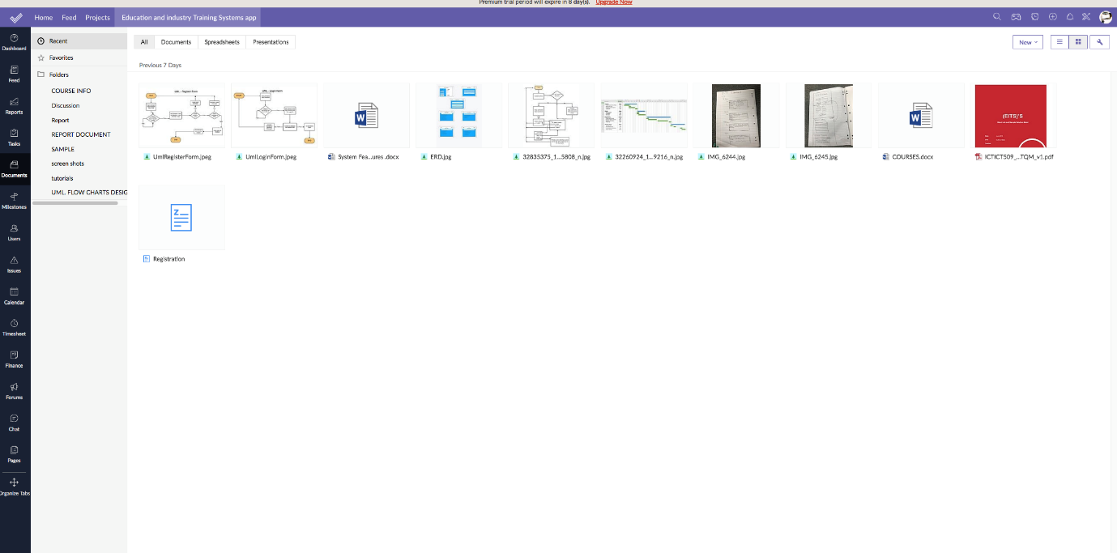

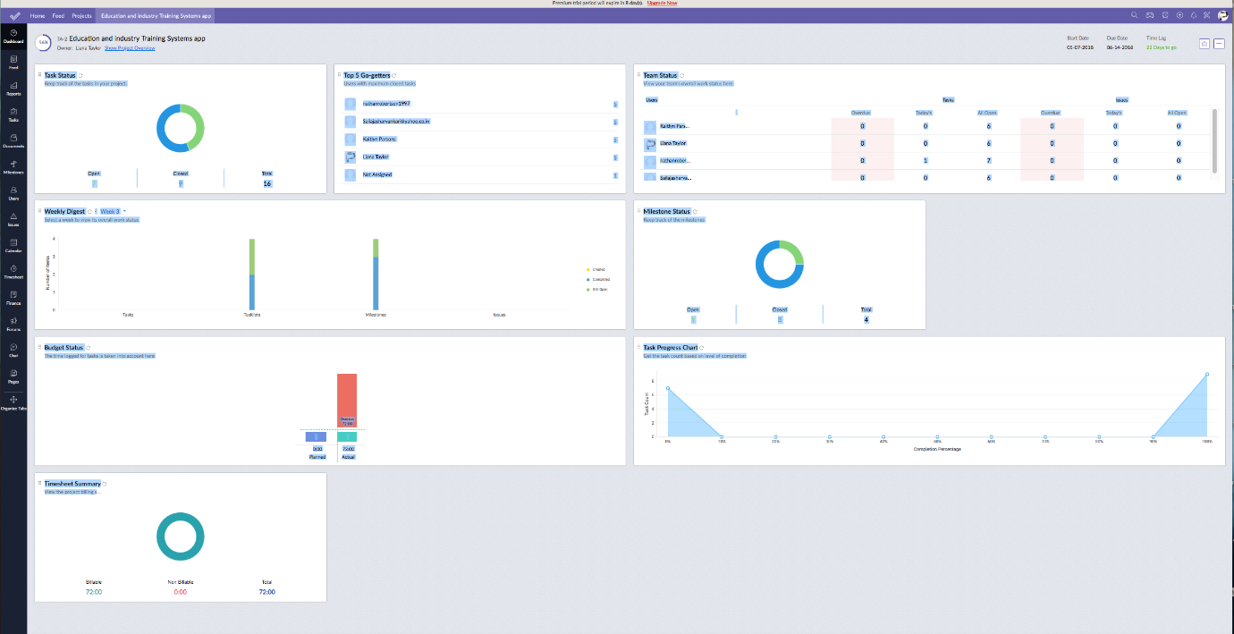

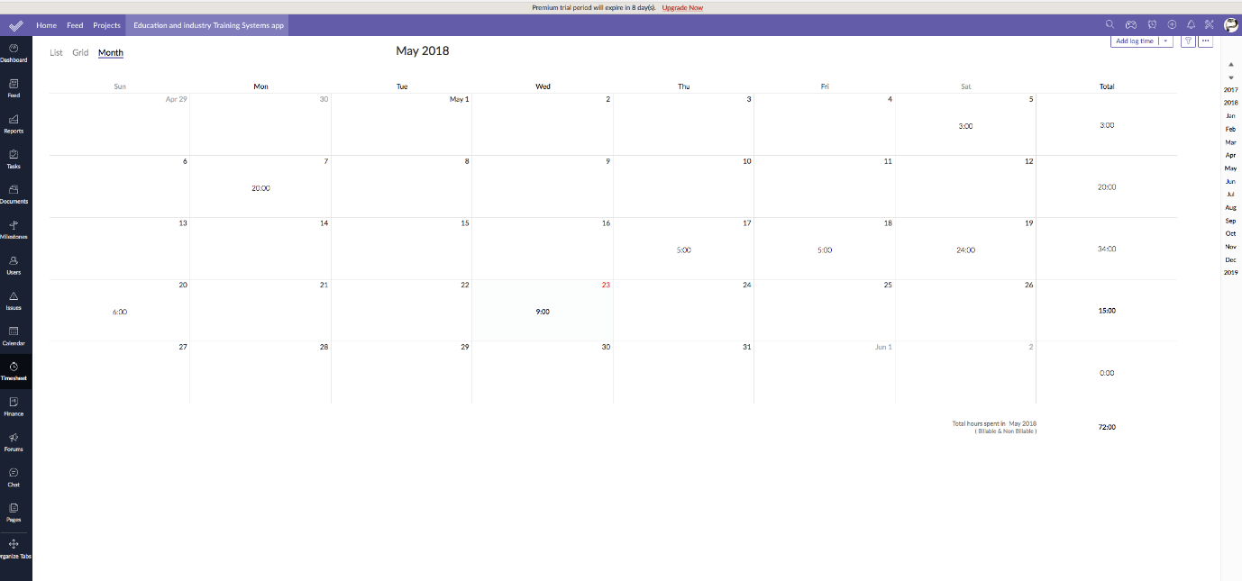

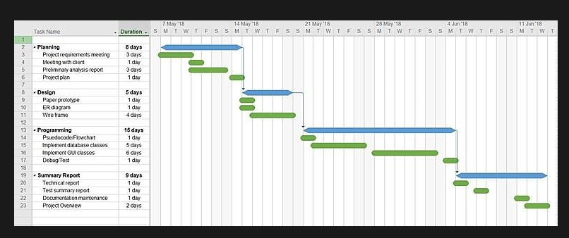

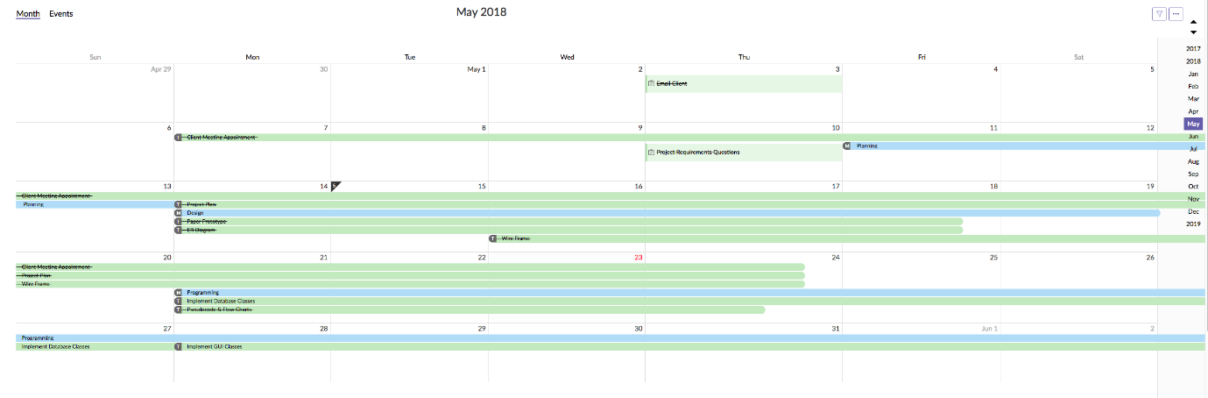

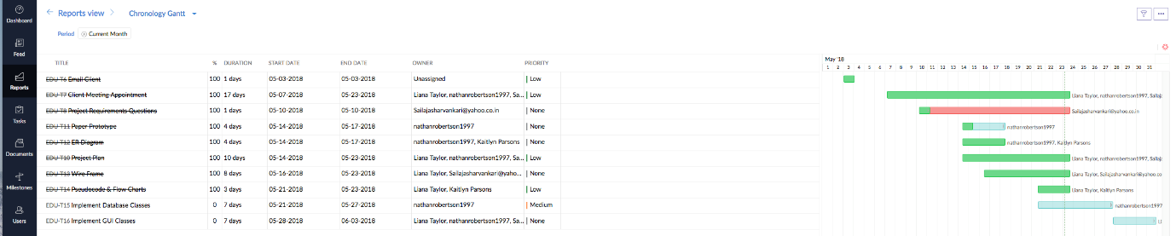

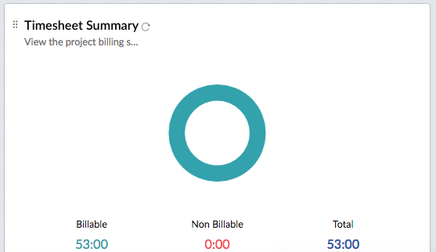



# **18. Expected Benefits and Issues**

**Expected benefits**

* Increase sales/enrolments
* Access to information
* Accessibility

**Expected Issues**

* The tables that contain student credentials in the staff panel doesn’t have the ability to scroll horizontally or vertically to view all the data past a certain point.
* The tables that contain course units in the course panel doesn’t have the ability to scroll horizontally or vertically to view all the data past a certain point.

# **List of References**

web links for all products used.

<https://www.zoho.com/>

<https://github.com/>

<https://www.sourcetreeapp.com/>

<https://www.jetbrains.com/idea/>

<https://java.com/en/download/>

<https://www.mamp.info/en/>